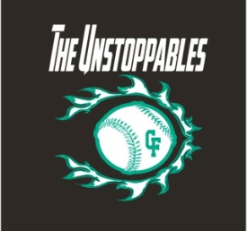
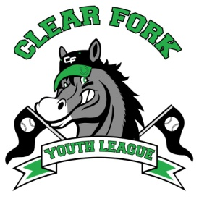
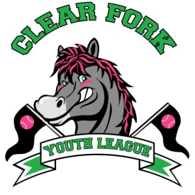
BOARD MEETING
OCTOBER 3, 2018
Attendance:
Jay Vail
Allen Leech
Ashley Ludwig
David Myers
Josh Smith
Carrie Knight
Lindsay Roberts
Niki Vail
Kyle Ludwig

- Allen gave an update
  - He has filed paperwork for 501c3, now we wait
  - Mentioned the Unstoppables need to decide if they want to be under the CFYL or file for their own EIN
  - Shared financial profit & loss statement for 2018

- Jay
  - Need to go over our mailing list for sponsors and update, possibly go into as many businesses as we can asking for sponsorships
  - Need to update the sponsorship forms
    - New Categories for donations
      - $750 Donation = Field named after sponsor, banner, and website advertisement
      - $400 Donation = Team, banner, and website advertisement
      - $250 Donation = Banner and website advertisement
      - $100 Donation = Website advertisement
    - Create open space for write-in donations.
    - Ashley will check into if sponsorships can be done online and create new sponsorship forms and letter.
  - Registration Dates – January 14, 2019 – March 17, 2019
  - Evaluation Dates – March 23, 2019. Baseball in the am, softball in the pm.
  - Draft Dates – March 30, 2019
  - Wade & Gatton will be paid to plant trees at ball fields for additional shade.
  - New Field 4 will need to have handicap accessible dugouts.
  - Look into replacing netting on current batting cage.
  - Potential Fundraisers
    - Golf Tournament
      - Possibly having our own instead of combining with Fredericktown
      - Possible Date – June 15, 2019
    - 5K on Saturday morning of the Bellville Fair
      - Clint Knight will head that up.
    - Softball tournament
      - Would need at least 4 fields for this to work.

- Next Board Meeting December 2018.

